**Assignment No: 7**

**Object Detection Using YOLO and Pretrained Model**

**Problem Statement:**

To implement an object detection system that identifies and locates objects in images or video streams using the YOLO (You Only Look Once) algorithm and a pretrained model.

**Objective:**

1. **To understand the principles of object detection and the YOLO algorithm.**
   * Grasp the underlying concepts of how YOLO works, including its architecture and grid division approach for real-time detection.
2. **To utilize pretrained models for efficient object detection.**
   * Leverage existing models that have been trained on large datasets to reduce training time and enhance detection accuracy.
3. **To evaluate the performance of the object detection model.**
   * Analyze model results using metrics to ensure reliable object detection capabilities.

**S/W Packages and H/W Apparatus Used:**

* **Operating System:** Windows/Linux/MacOS
* **Kernel:** Python 3.x
* **Tools:** Jupyter Notebook, Anaconda, or Google Colab
* **Hardware:** CPU with minimum 4GB RAM; optional GPU for faster inference

**Libraries and Packages Used:**

* **OpenCV:** For image processing and video handling.
* **TensorFlow/Keras or PyTorch:** Frameworks for implementing and running deep learning models.
* **NumPy:** For numerical operations and array handling.
* **Matplotlib:** For visualizing results and data.

**Theory:**

1. **YOLO (You Only Look Once):**
   * YOLO is a real-time object detection algorithm that divides an image into a grid. Each grid cell predicts bounding boxes and class probabilities for objects whose center falls within the cell. This unique approach allows YOLO to detect multiple objects simultaneously and efficiently.

**Methodology:**

1. **Data Acquisition:**
   * Load images or video streams for object detection. This can include various sources, such as video files, webcam feeds, or static images.
2. **Preprocessing:**
   * Resize and normalize images according to the YOLO model's input requirements (e.g., typically 416x416 pixels). This ensures consistent input sizes for the model and improves detection performance.
3. **Model Setup:**
   * Download and load a pretrained YOLO model (e.g., YOLOv3, YOLOv5). Utilizing a pretrained model allows for faster development and often better performance than training a model from scratch.
4. **Object Detection:**
   * Pass the images through the YOLO model to detect objects. The model will output bounding boxes, class labels, and confidence scores for each detected object.
5. **Post-Processing:**
   * Apply Non-Maximum Suppression (NMS) to eliminate duplicate bounding boxes for the same object, ensuring that only the most confident detections are retained.
6. **Display Results:**
   * Draw bounding boxes and class labels on the original images or video frames, visualizing the detected objects and their locations.
7. **Evaluation:**
   * Compute metrics like mean Average Precision (mAP) to assess the model's performance. This involves comparing the detected bounding boxes to ground truth annotations to measure accuracy and reliability.

**Working Algorithm:**

1. **Import Libraries:**
   * Import necessary libraries: OpenCV, TensorFlow/Keras or PyTorch, NumPy, Matplotlib.
2. **Load the YOLO Model:**
   * Download and load a pretrained YOLO model (e.g., YOLOv3, YOLOv5) using appropriate framework functions.
3. **Prepare the Input:**
   * Read images or video streams using OpenCV (cv2.VideoCapture() for video).
   * Resize images to the input size required by the YOLO model (e.g., 416x416 pixels).
4. **Object Detection:**
   * Pass the images through the YOLO model to get predictions (bounding boxes, class labels, confidence scores).
5. **Post-Processing:**
   * Apply Non-Maximum Suppression (NMS) to eliminate duplicate bounding boxes using cv2.dnn.NMSBoxes().
6. **Display Results:**
   * Draw bounding boxes and class labels on the original images using cv2.rectangle() and cv2.putText().
7. **Evaluation:**
   * Compute metrics like mean Average Precision (mAP) to assess the model's performance by comparing detected boxes with ground truth.
8. **Visualize Results:**
   * Display the processed images or video frames with bounding boxes using OpenCV (cv2.imshow()).

**Advantages:**

* **High Accuracy and Speed:** YOLO is designed for real-time detection, achieving a high frame rate while maintaining accuracy, making it suitable for applications that require immediate responses.
* **Multiple Object Detection:** The algorithm can detect and classify multiple objects within a single image simultaneously, providing comprehensive scene understanding.

**Limitations:**

* **Performance Variability:** The accuracy of detection can be influenced by image resolution, lighting conditions, and occlusion, affecting the model's reliability in diverse environments.
* **Resource Intensive:** Real-time applications may require significant computational resources, particularly when processing high-resolution images or video streams.

**Disadvantages:**

* **Trade-off Between Speed and Accuracy:** While YOLO is efficient, there may be trade-offs regarding detection accuracy, particularly in small object detection compared to other algorithms.
* **Complexity in Configuration:** Setting up YOLO with optimal configurations may require experience and understanding of various hyperparameters, which can be challenging for beginners.

**Applications:**

* **Autonomous Vehicles:** Object detection is crucial for identifying obstacles and other vehicles in self-driving applications.
* **Surveillance Systems:** YOLO can be used for monitoring and identifying persons or objects of interest in real-time.
* **Industrial Automation:** Detecting items on assembly lines or identifying defective products during manufacturing processes.

**Working Algorithm:**

1. **Import Libraries:**
   * Import OpenCV, TensorFlow/Keras or PyTorch, and other required libraries.
2. **Load the YOLO Model:**
   * Download and load a pretrained YOLO model.
3. **Prepare the Input:**
   * Read images or video streams.
   * Resize images according to the model's input requirements.
4. **Object Detection:**
   * Pass the images through the YOLO model.
   * Retrieve bounding boxes, class labels, and confidence scores for detected objects.
5. **Post-Processing:**
   * Apply Non-Maximum Suppression (NMS) to remove duplicate detections.
6. **Display Results:**
   * Draw bounding boxes and class labels on the original images and visualize the results.
7. **Evaluation:**
   * Compute metrics like mean Average Precision (mAP) to assess model performance.

**Diagram:**

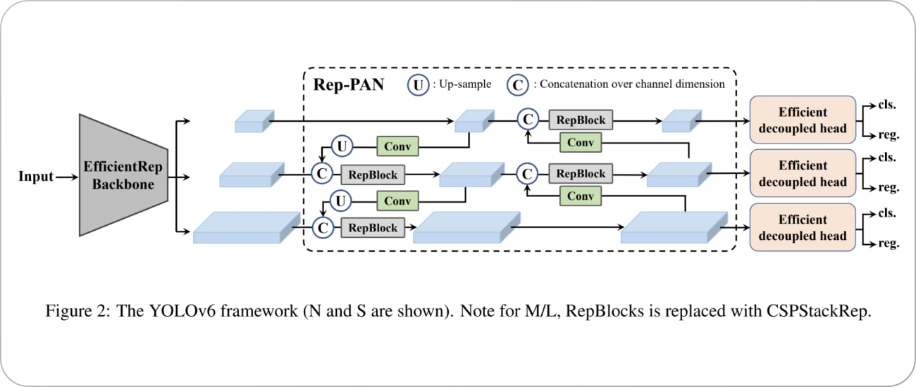

**Conclusion:**

Object detection using the YOLO algorithm and pretrained models provides a powerful and efficient solution for real-time detection tasks across various applications. Its ability to identify and locate multiple objects in a single pass ensures rapid processing, making it ideal for scenarios such as surveillance, autonomous driving, and industrial automation.

By leveraging advanced deep learning techniques, YOLO demonstrates significant improvements over traditional object detection methods, transforming how we interact with and analyze visual data. However, performance can be influenced by factors like resolution, lighting conditions, and model configuration, which necessitates ongoing research and refinement.

Future advancements in YOLO and similar algorithms will continue to enhance object detection capabilities, pushing the boundaries of automation and artificial intelligence across industries. As we further integrate these technologies into real-world applications, the potential for increased efficiency and enhanced data analysis will continue to grow.